Purpose
To increase awareness of the medical evidence for follow-up testing, improve communication between rendering and ordering physicians, reduce unnecessary patient radiation exposure, improve the cost effectiveness of lung nodule evaluation, and increase primary care physician comfort with managing this evaluation while maintaining a high level of sensitivity in early diagnosis of the few lung cancers that are found among this cohort of patients.

Overview
Small pulmonary nodules are common incidental findings on chest and abdominal CT scans. Lung cancer screening CT trials have demonstrated that up to 51% of smokers, over 50 years of age, will have one or more such nodules, the vast majority of which are benign. The risk of malignancy as a cause of any such nodule in these high-risk populations is best correlated with nodule size.
Past recommendations, based largely on pre-CT era follow-up of lung nodules seen on chest radiograph (CXR), called for a large number of follow-up studies to be performed resulting in additional radiation exposure, and have not clearly demonstrated improvements in long term health outcomes nor to be cost-effective.

The Monroe County Medical Society through its Quality Collaborative has adopted the 2017 Fleischner Society Guideline (1) recommendations for follow up and management of incidentally found lung nodules. The updated guidelines provide greater flexibility in follow-up regarding nodule characteristics. These guidelines are based on a greatly improved understanding of the natural history of solid and subsolid (pure ground glass and part-solid) lung nodules gleaned from CT based lung cancer screening trials performed over the last decade. This data suggests that solid nodule follow up intervals and duration can be individualized based on patient risk factors for lung cancer, nodule size and nodule characteristics. The follow up intervals for subsolid nodules is based solely on nodule size with longer time intervals for a longer duration.

It is strongly emphasized that incidentally detected lung nodules are not applicable to a lung screening program¹ and are managed differently. Lung-Rads assessment is utilized for dedicated lung cancer screening CT exams. The following ACR website link contains detailed information regarding the Lung- RADS CT Screening Reporting & Data System: (https://www.acr.org/QualitySafety/Resources/LungRADS).

Recommendations

The following recommendations were developed to help physicians implement the Community Guidelines through a standardized process. Pay close attention to the two entirely separate sections on the chart on page 4, one addressing the management of solid and the other subsolid nodules. Please note that these recommendations include those specific for the radiologist such as CT technique, nodule characterization and impression reporting as well as topics more germane to the clinician such as interval follow up recommendations, lung cancer risk stratification, and cautionary notes.

¹ See MCMS Community-wide guideline, Lung Cancer Screening for reference

CT Technique

The CT scans should use techniques designed to reduce radiation dose while maintaining adequate image quality (As Low As Reasonably Achievable - ALARA). The use of dose modulation software and post processing algorithms may result in a further reduction in dose and are encouraged where available.

For consistency, it is recommended the patient be scanned lung apices to bases and images be reconstructed at 2 mm every 1 mm for solid nodules and at 1 mm every 1 mm for subsolid nodules.

Follow-up exams should be done without IV contrast. Nodule Characterization
For these guidelines, manual nodule measurements should be based on the average of long- and short-axis diameters, both of which should be obtained on the same transverse, coronal, or sagittal reconstructed images. Whichever image reveals the greatest dimensions is the image that should be used. Measurements should be made with electronic calipers or semiautomated methods and should be recorded to the nearest whole millimeter.

Reporting

For most small solid nodules (less than 6mm), the Fleischner Society does not recommend any further investigation on the basis of the estimated low risk of malignancy for these lesions. For intermediate-size (6- 8mm) nodules, the Fleischner Society recommends follow-up CT of the complete chest after an appropriate interval (3-12 months depending on clinical risk) to confirm stability and to evaluate additional findings. If nodule stability can be demonstrated on the basis of retrospective comparison with a previous study, that may suffice. However, the stability of a nodule should be demonstrated for at least 2 years to suggest more likely benign etiology. In the case of a large (>8 mm) or very suspicious nodule, the Fleischner Society recommends proceeding with a complete thoracic CT examination for further evaluation.

For subsolid nodules, while the presence of a solid component to a subsolid nodule has been shown to increase the likelihood of an invasive carcinoma, solid components measuring < 6 mm more often represent carcinoma-in-situ or minimally invasive carcinoma and are best managed conservatively.
Multiple part-solid nodules with a solid component that changes from < 6mm to > 6mm have been found to represent multiple synchronous primary lung cancers. Aggressive lung sparing resection of these lesions has been shown to be clinically beneficial for all histologies except mucinous adenocarcinoma. It has also been shown that delaying surgical resection until there is evidence of interval growth produced no adverse effect on patient outcome. (3)

As noted previously, the presence of a part-solid component increases the likelihood of invasive carcinoma which is especially true if the solid component is 6 mm or larger prompting a variable work-up strategy based on the size of the solid component.

Notes:
- There are no data at present to suggest that traditional risk factors for lung cancer, such as smoking history or family history, are applicable to subsolid nodules. Therefore, work-up of subsolid nodules is not stratified by cancer risk factors at this time.
- Subsolid nodules, especially pure GGN’s, exhibit an indolent growth pattern if persistent with doubling times of 3-5 yrs. Therefore, follow-up of subsolid nodules is performed less frequently but for a longer duration than solid nodules.

High risk is defined as one or more of the following:
  - >30 pack year smoking history or equivalent second-hand exposure
  - Family history of lung cancer
  - Occupational Exposure (asbestos, beryllium, silica, uranium, radon)
  - Chronic Interstitial/Fibrotic Lung Disease
  - Prior history of cancer within the last 5 years

Low risk is defined as:
  - Minimal or absent history of smoking or other known risk factors

Cautionary Notes:
- High risk nodules should be followed until deemed to be benign.
- Caution is advised in the setting of fever/immunocompromised state which may require early pulmonary evaluation or follow-up CT based on clinical concern for pulmonary infection.
- These guidelines may not apply for individuals with known or suspected malignant disease

In the Findings section of the report, define:

Size:
Determined by the average of length and width of largest nodule identified in any of the 3 imaging planes. Volume measurements can be used but are subject to additional observer measurement variation and different software programs can further contribute to variability in measurements, consequently the use of the average diameter is more commonly reported.

Characteristics:
- Composition: solid, ground-glass, mixed, calcified, fatty, enhancement, cavitary
- Borders: sharp, lobulated, spiculated, indistinct
- Calcification: none, benign pattern, indeterminate
- Location: lung, lobe
- Image location: series and image number

Temporal Change (if applicable):
A pulmonary nodule can be determined to have changed in size when its average diameter has increased or decreased by at least 2mm (rounded to the nearest millimeter). Smaller changes in measured diameter can be spurious, especially for ill-defined nodules and do not reliably indicate change. If incidental nodules are noted on a CT abdomen for which further evaluation is deemed appropriate, based on patient age and indication for abdominal CT, a dedicated diagnostic CT scan of the chest would be in order.

These guidelines will not apply to every clinical situation. There may be specific cases where these general guidelines should not be followed. Whenever a provider makes a medical judgment that the guidelines should not be followed in the case of a specific patient this should be noted as an exception and the rationale for that judgment should be documented in the patient’s medical record.

The appropriate recommendation based on the nodule to be followed should be incorporated in every report. If risk factors are unknown; report both follow-up options. Below are the Fleischner Society Guidelines adopted by the MCMS for newly detected indeterminate nodule(s) in persons 35 years of age or older. The recommended follow up is based on the size of the largest indeterminate nodule and, for solid nodules, whether or not the patient is considered at low or high risk. In the occasion there are solid and subsolid nodules, both guidelines should be followed and combined when possible. Please note that in individual circumstances exceptions may be made in assessment of a single case.

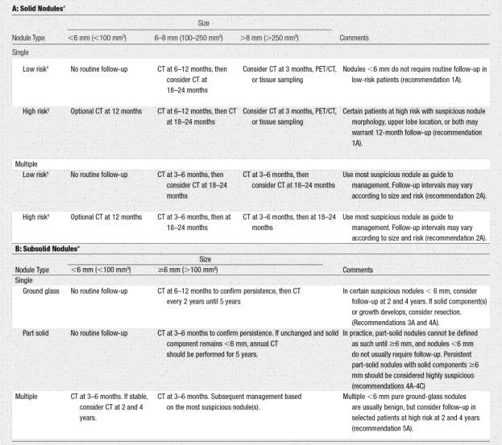

Note: These recommendations do not apply to lung cancer screening; patients with immunosuppression, or patients with known primary cancer.
*Dimensions are average of long and short axes, rounded to the nearest millimeter.
†Consider all relevant risk factors (see Risk Factors).

- †MacMahon H, Naidich D P, Goo J M, et al. Guidelines for management of incidental pulmonary nodules detected on CT images: From the Fleischner Society 2017. Radiology DOI: 10.1148/radiol.2017161659. Published online February 23, 2017. © RSNA.

References

  - MacMahon, H, Naidich DP, Goo, JM et al. Guidelines for Management of Incidental Pulmonary Nodules Detected on CT Images: From the Fleischner Society 2017, Radiology DOI:10.1148/radiol.2017161659

  - Greenberg AK, Lu F, Goldberg JD, Eylers E, Tsay J-C, et al. CT Scan Screening for Lung Cancer: Risk Factors for Nodules and Malignancy in a High-Risk Urban Cohort. PLOS ONE 2012;7(7): e39403.doi:10.1371/journal.pone.0039403.

  - Feely, MA, Hartman TE. Inappropriate Application of Nodule Management Guidelines in Radiologist Reports Before and After Revision of Exclusion Criteria. AJR 2011; 196: 1115- 1119

